**Covid Case using DataBricks**

**By using Pyspark:**

**List the files in DataBricks:**

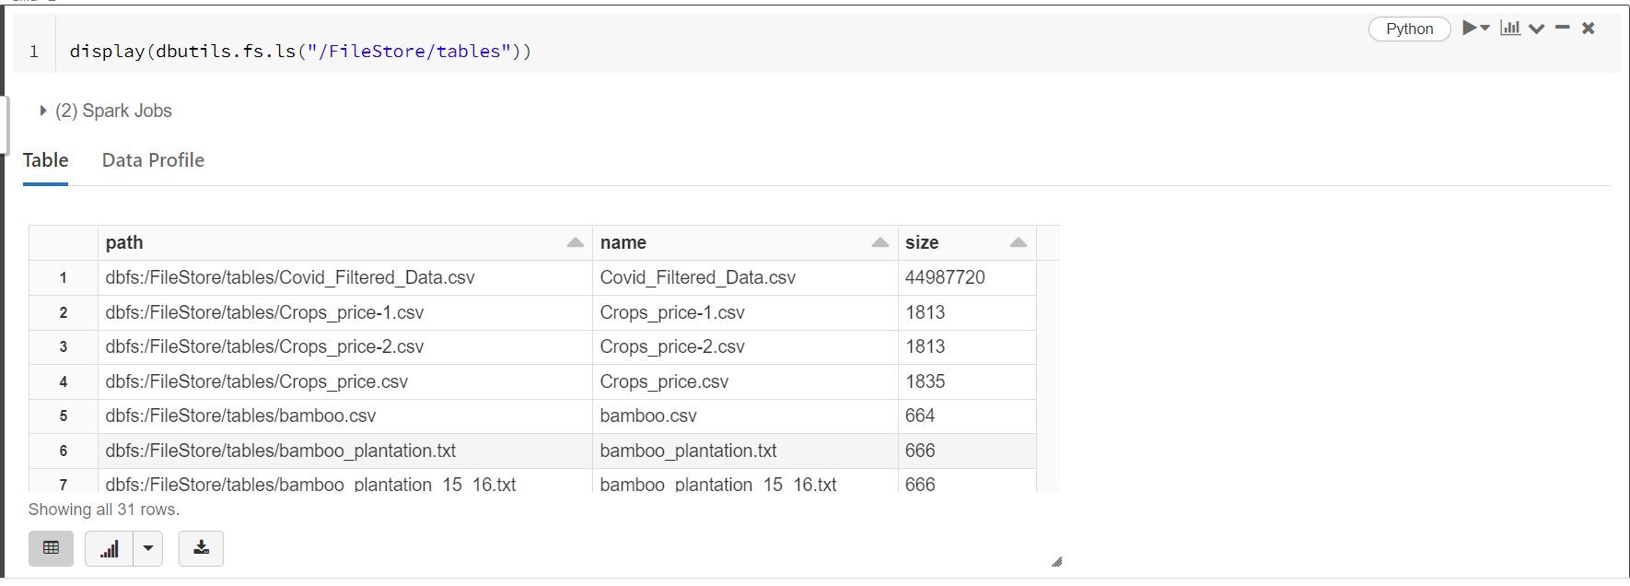

**Reading the file:**

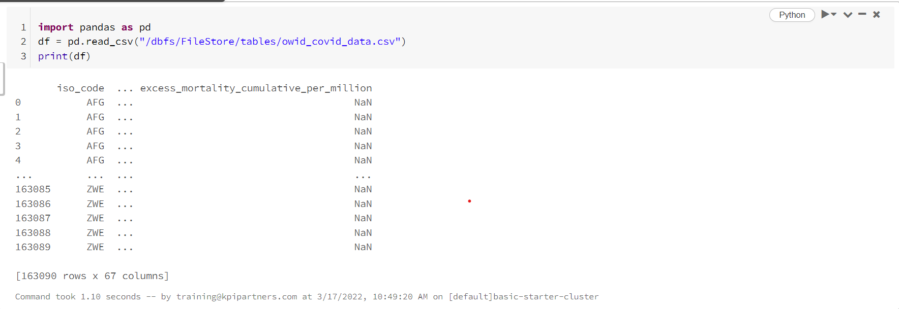

**1. Remove the records where the continent column having blanks.**

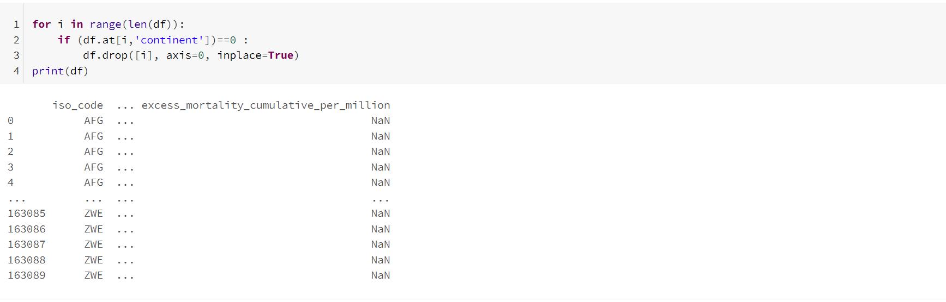

**2. Replace all the NEGATIVE and NULL valued records with 0.**

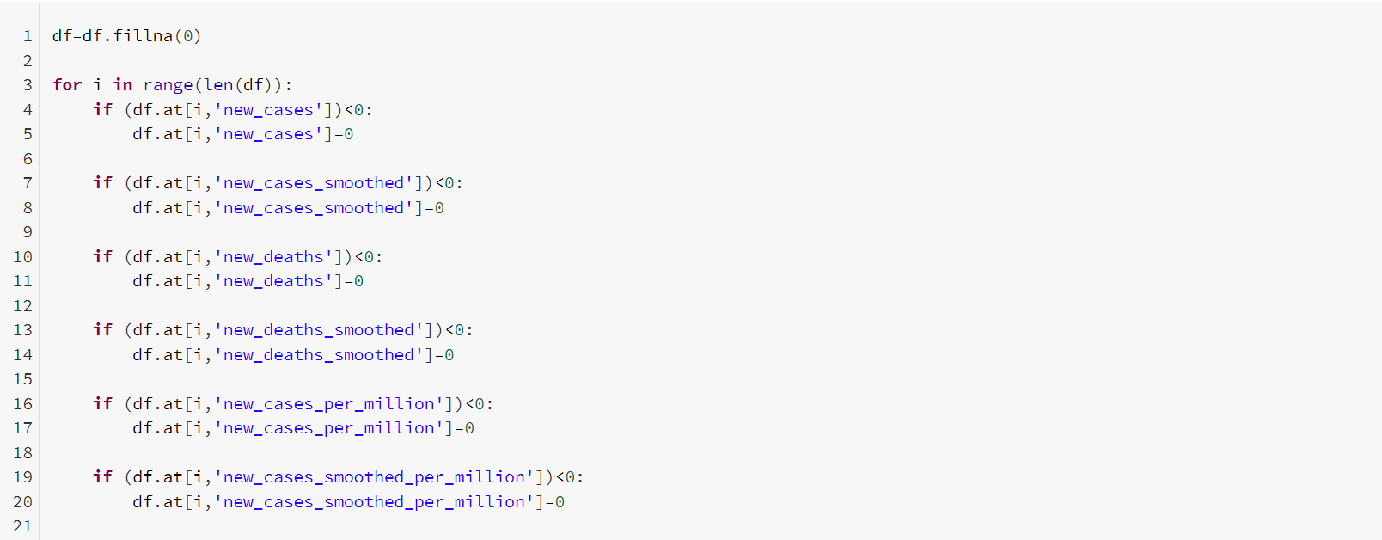

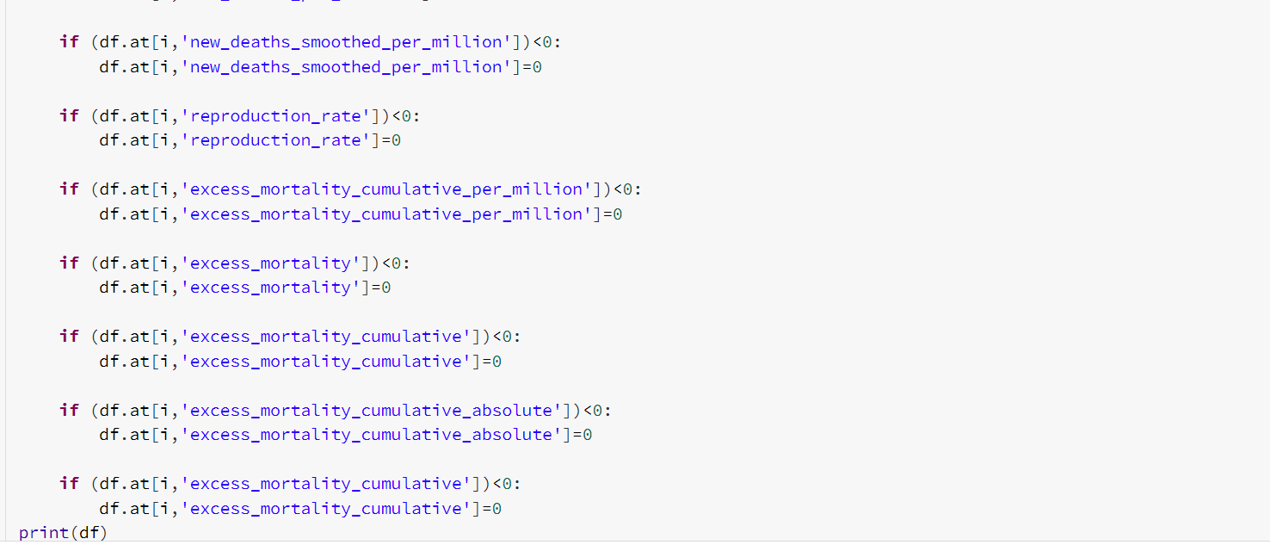

**Reading the file for quering:**

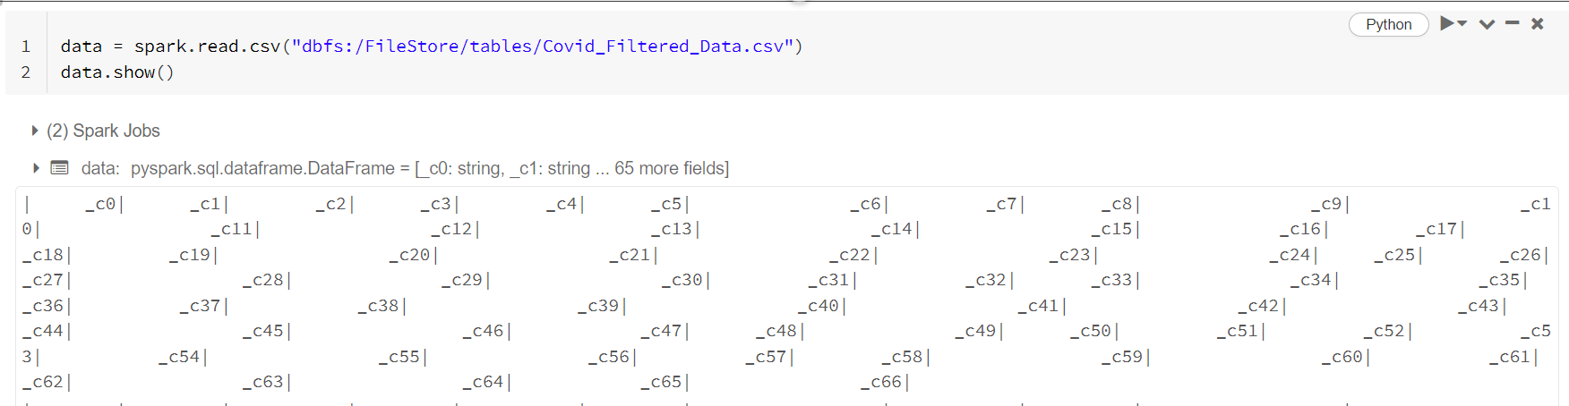

**Creating Temporary View:**

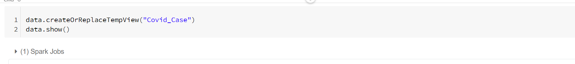

**3. Positivity rate where the strigency index is maximum.**

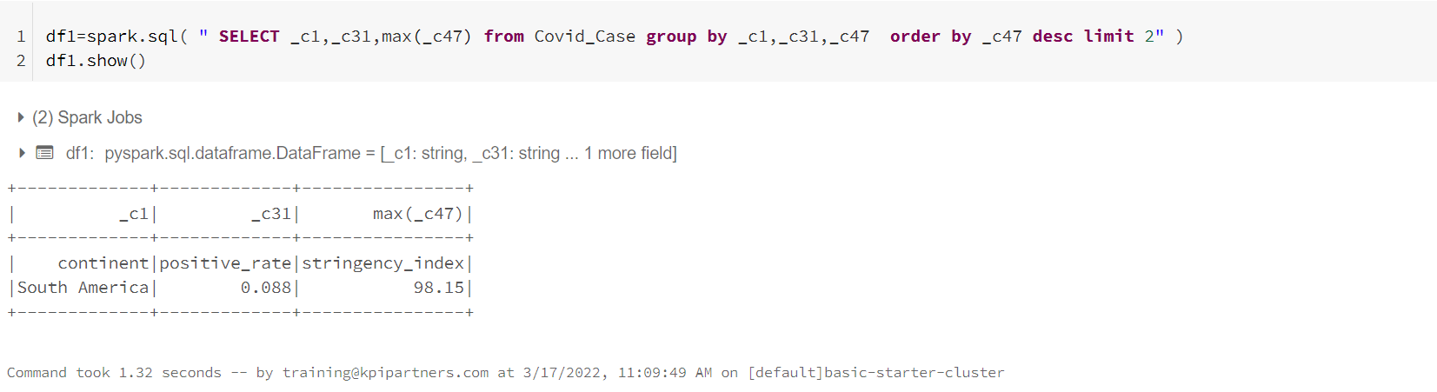

**4. Which continent and location having max of deaths and male_smokers.**

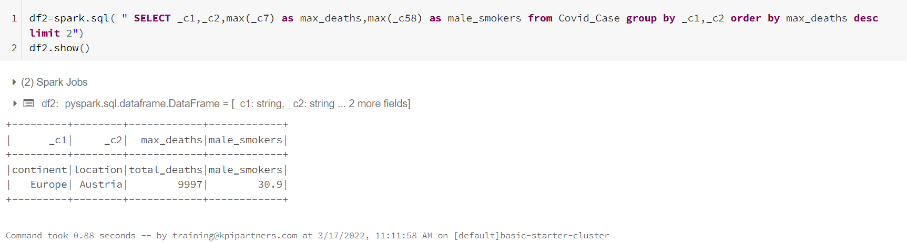

**5. Which year having the highest number of deaths.**

